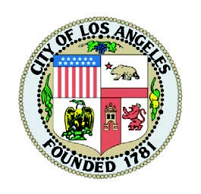
LOS ANGELES RECONNECTIONS CAREER ACADEMY (LARCA)2.0

JOBS AND EDUCATION PROGRAM

FOR CLASS MEMBERS OF THE RODRIGUEZ SETTLEMENT
MEDIA CONSENT FORM
I give my consent to be interviewed, videotaped and / or photographed for use by the LOS ANGELES RECONNECTIONS CAREER ACADEMY (LARCA) 2.0. I understand that my interview, video, and/or photographic image may be used in print or digital/electronic form (e.g., publications, website, advertising, videos) and may recognize my association with the City of Los Angeles, including the LOS ANGELES RECONNECTIONS CAREER ACADEMY (LARCA)2.0 program.

Full Name (print)________________________________________________________________
Adress________________________________________________________________________
City________________________________ State__________ Zip code_____________________
Phone_________________________ E-mail Address___________________________________
Signature____________________________________________ Date______________________

Minor Consent: If you are a parent/ legal guardian signing on behalf of a minor (less than 18 years old), please also complete the portion below.
Minor’s Full Name (print) _________________________________________________________
Relationship to person completing this form__________________________________________

_____________________________________________________________________________________________________
For Staff Use Only
Name of LARCA 2.0 Service Provider: ___________________________________________________________
Name of staff Submitting Success Story: ______________________________________________________

